**Hosting a static website on AWS S3**

Amazon s3(**Simple Storage Service**) is an object storage service provided by AWS. It allows you to store and retrieve any amount of data at any time, from anywhere on the web.

S3 is highly scalable, reliable, fast and secure, making it a popular choice for storing data such as backups, static website files and large datasets.

An S3 bucket is essentially a container for objects stored in Amazon S3. You can think of a bucket as a folder in your file system, where you can store an unlimited number of objects, such as files or data blobs

S3 stores data as objects, which consists of the data itself, a key(Identifier)

Types:

**🡺 Standard Bucket(S3 Standard)**

General-purpose storage for frequently accessed data.

High durability, availability and performance for frequently accessed data

Its ideal for use cases like content distribution, big data analytics and mobile and gaming applications

**🡺 S3 Glacier**

Archival storage for data that is rarely accessed but requires long-term retention

Extremely low-cost storage for data archiving with retrieval times ranging from minutes to hours

🡺 S3 Glacier Deep Archive

The lowest-cost storage option, intended for data that is very rarely accessed

Ideal for long-term retention of data that doesn’t need to be accessed more than once or twice a year, with retrieval times of 12 hours or more

**Differences from Traditional Storage**

1. **Scalability**:
   * **Traditional Storage:** Limited by physical hardware constraints.
   * **S3:** Virtually unlimited storage capacity, scaling automatically as you add more data.
2. **Access and Availability**:
   * **Traditional Storage:** Limited to local access or through VPNs for remote access.
   * **S3:** Accessible from anywhere via the internet, with high availability and durability ensured by replicating data across multiple locations.
3. **Cost Efficiency**:
   * **Traditional Storage:** Often involves higher upfront costs for hardware, maintenance, and operation.
   * **S3:** Pay-as-you-go pricing model, with different storage classes for different access needs, helping to optimize costs.
4. **Data Management**:
   * **Traditional Storage:** Manual management of storage infrastructure, backup, and recovery.
   * **S3:** Automated data management features, such as lifecycle policies, versioning, and replication.

**Steps to host static website in S3**

Step1: Sign in to AWS console

Step2: Create an S3 Bucket

In AWS management console, search for and select “S3” service.

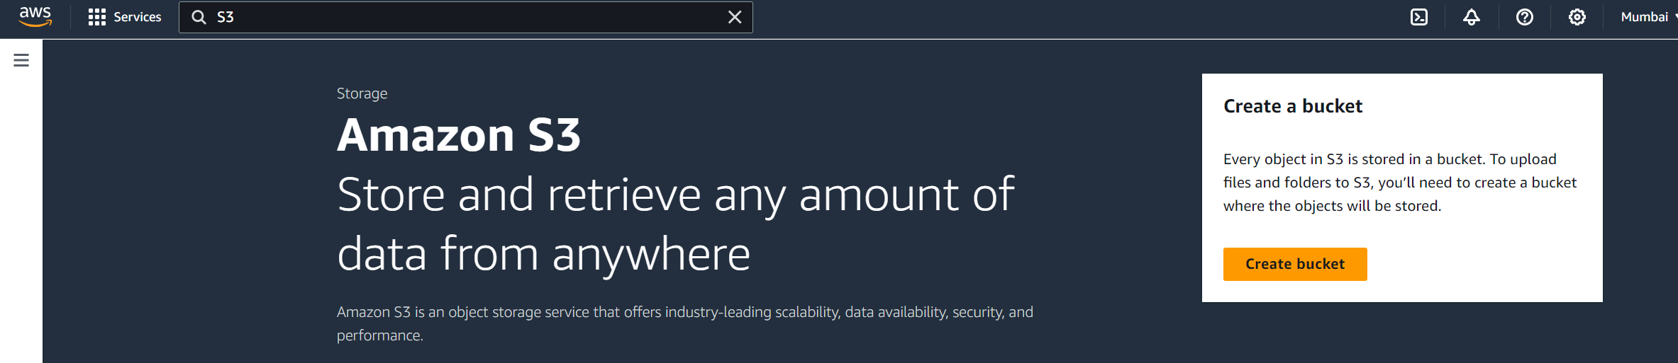



Click on “Create Bucket” button

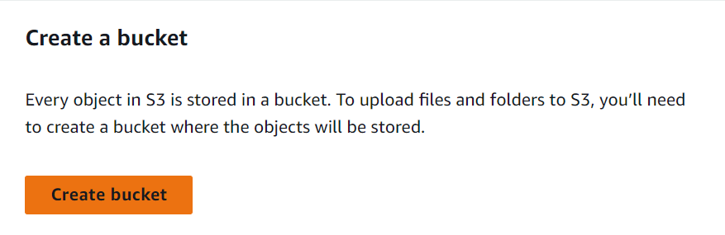

Now choose your bucket name

Note: Bucket name must be unique within the global namespace (i.e., it should be unique)

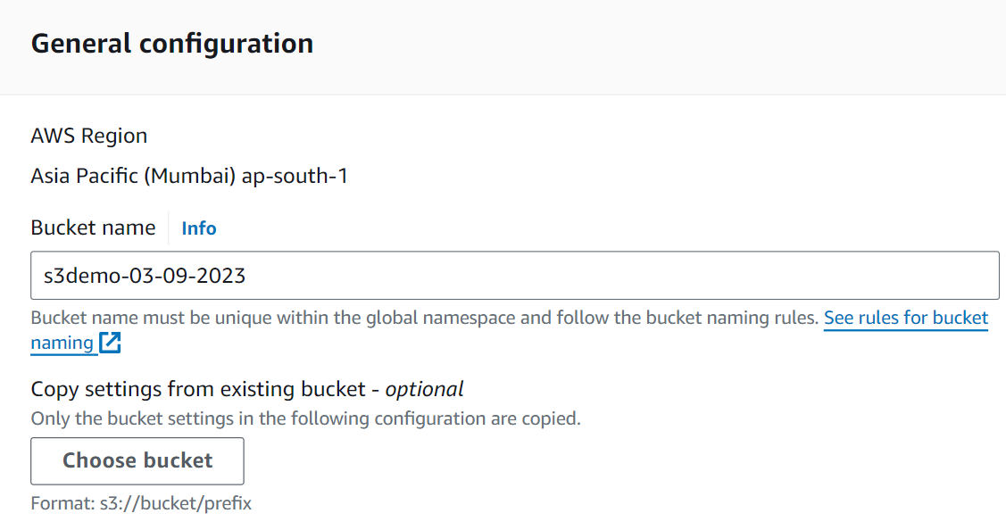 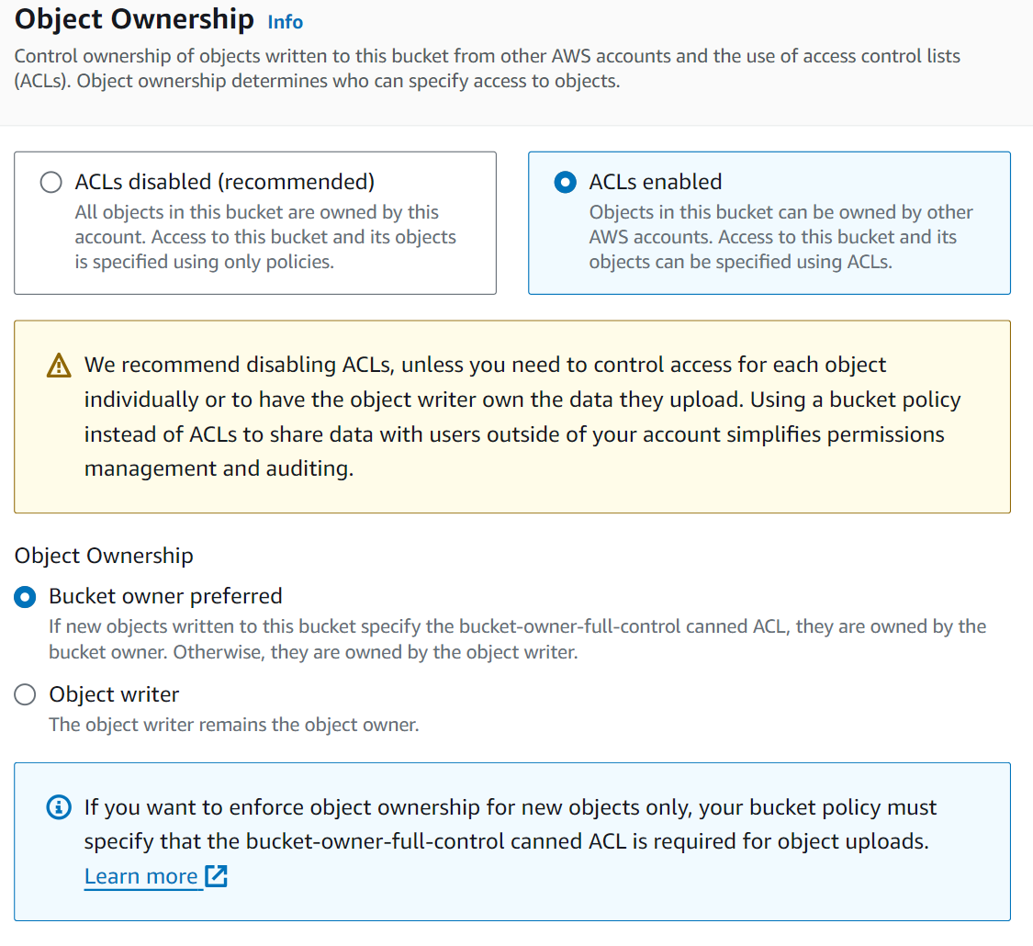

Remove check button on “Block all public access” and click on “I acknowledge”

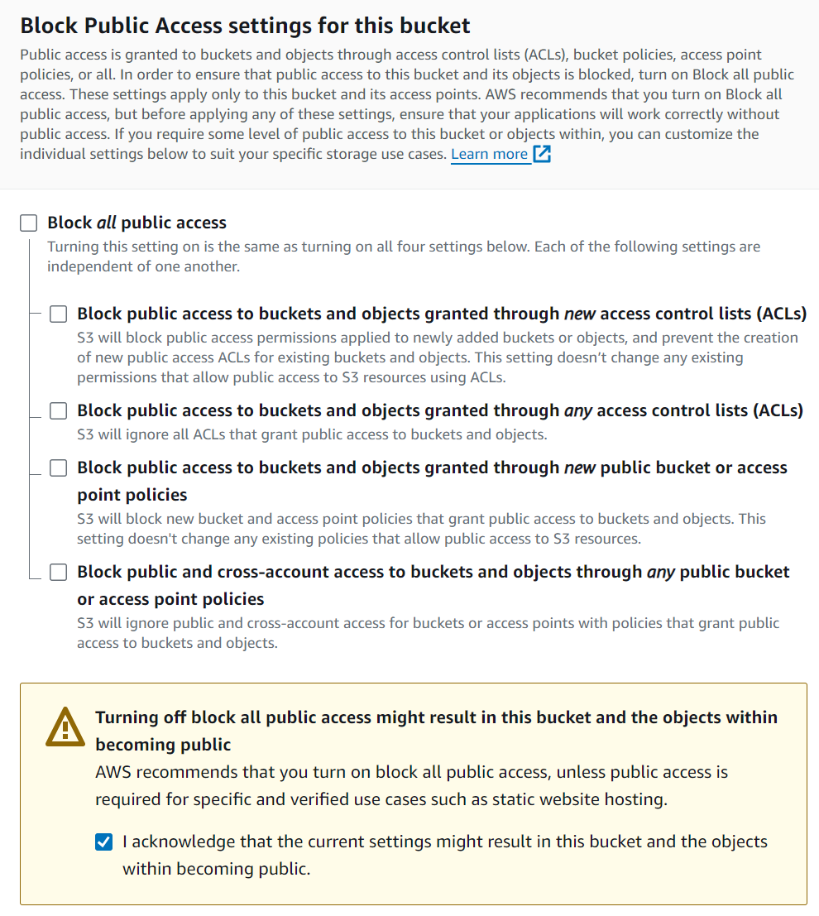



And let the remaing configuration un altered and then click on “create bucket” button on the bottom of the page

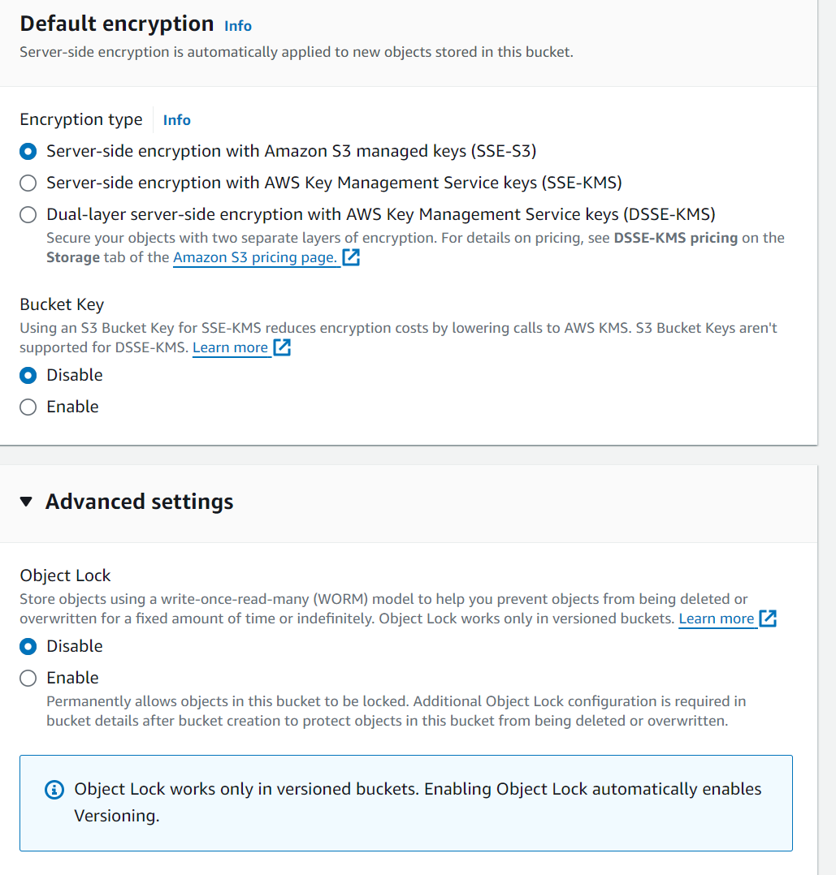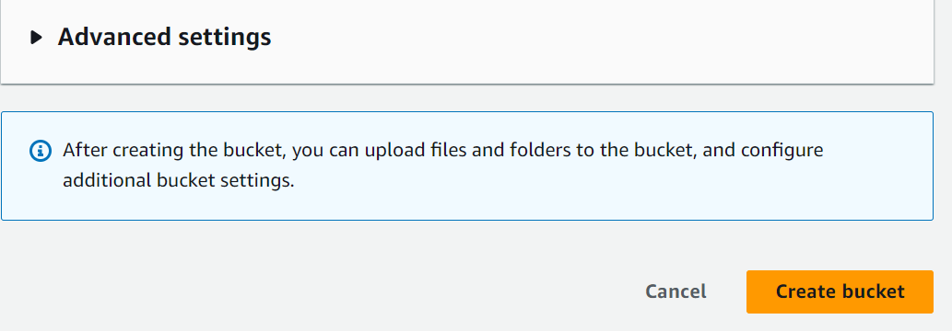

After selecting “create bucket” option, you will be redirecting to a page showing that your bucket has been deployed

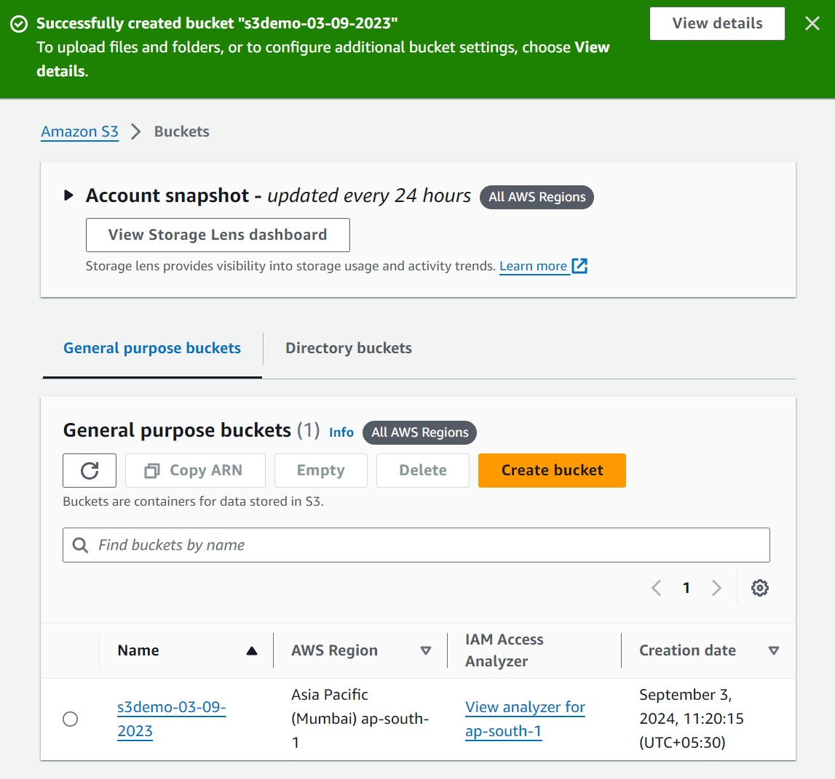



**Step3:**

1)Once your bucket is created, select it from the list of buckets

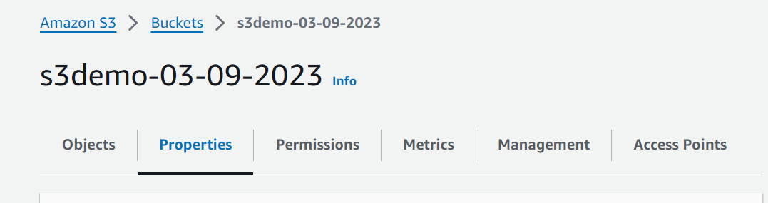

2)Go to the “properties” tab and enable “Static website hosting”

Initially it is set to “disabled”, we need to make it enabled

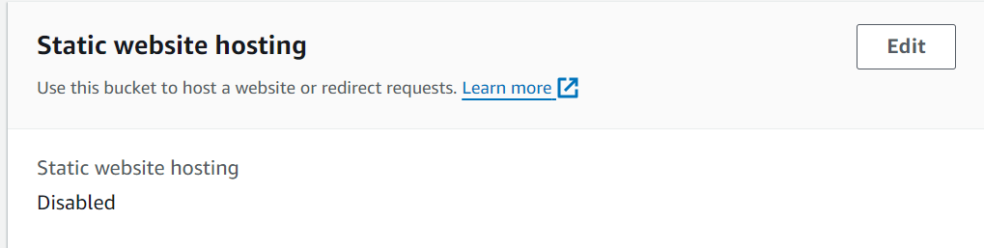

3)Enter the “Index document”

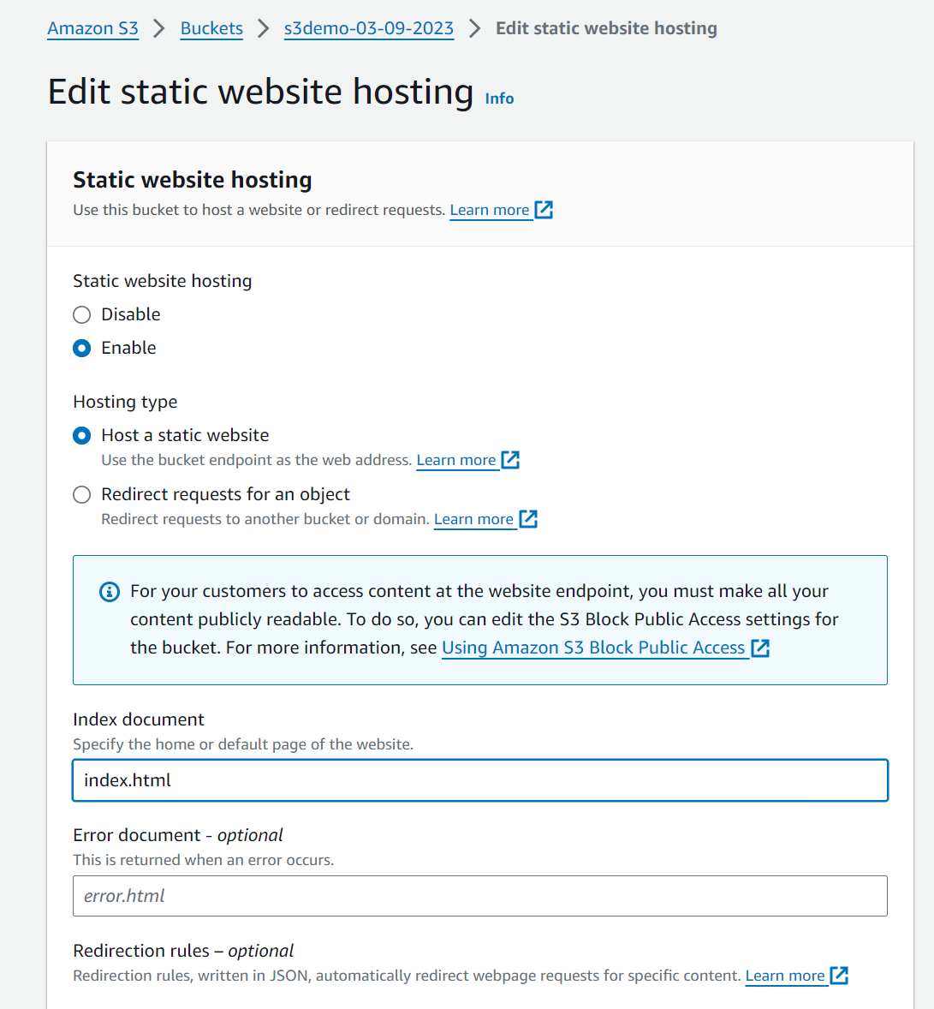



**And Then click on “save changes”, in order to save the modifications made.**



**Step 4: Upload your website files**

1. **Go to the “overview” tab of your bucket**

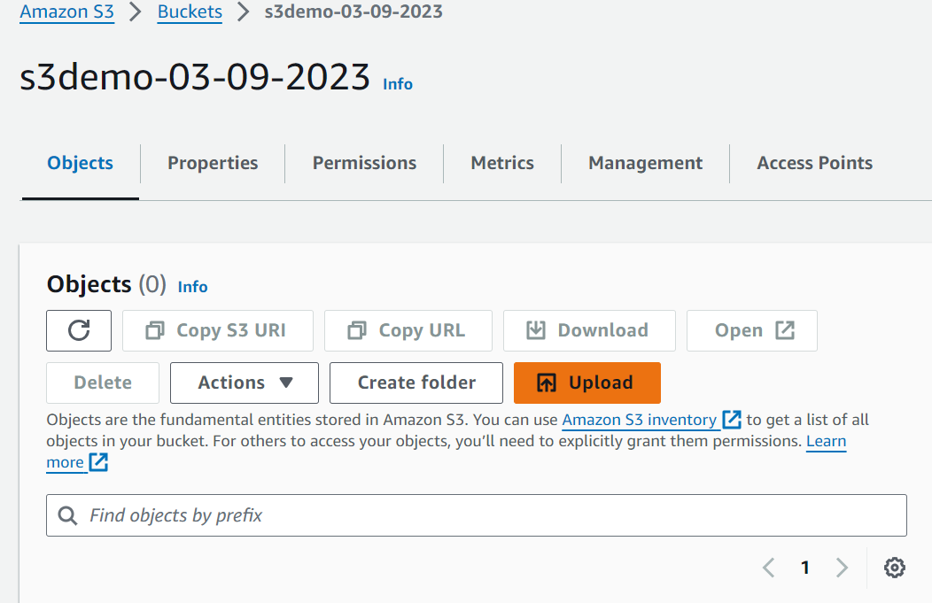



1. **Click the ‘’Upload” button to add your static website files(HTML, CSS, JS, Images, etc.)**

**You can either add files or folder via “drop and drag”**

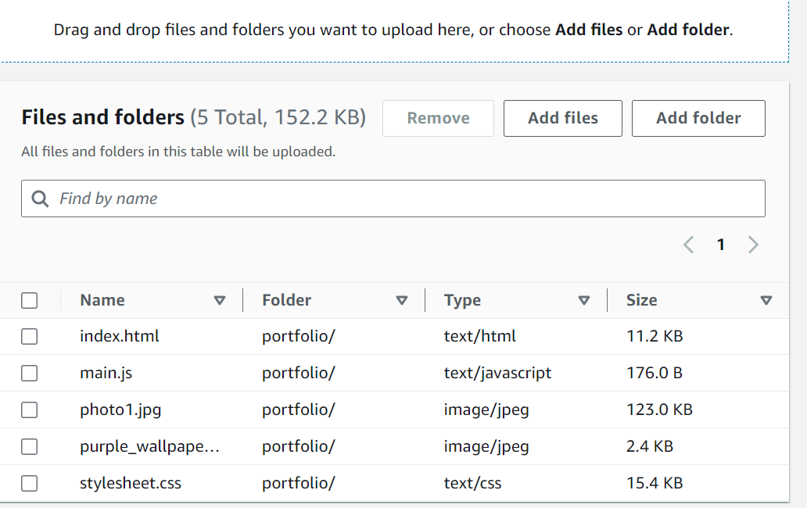



**Step 5: Making uploaded objects Pubic**

1. **Select the uploaded files in your bucket**
2. **Go to the “Actions” dropdown and choose “Make public”**

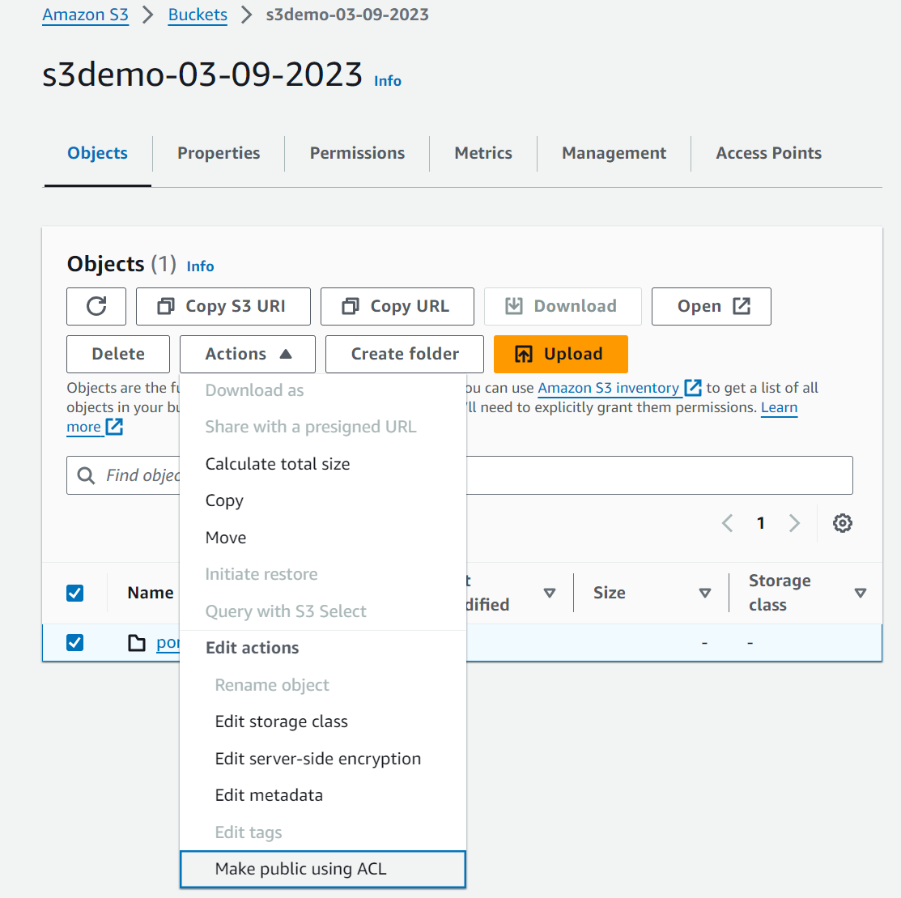



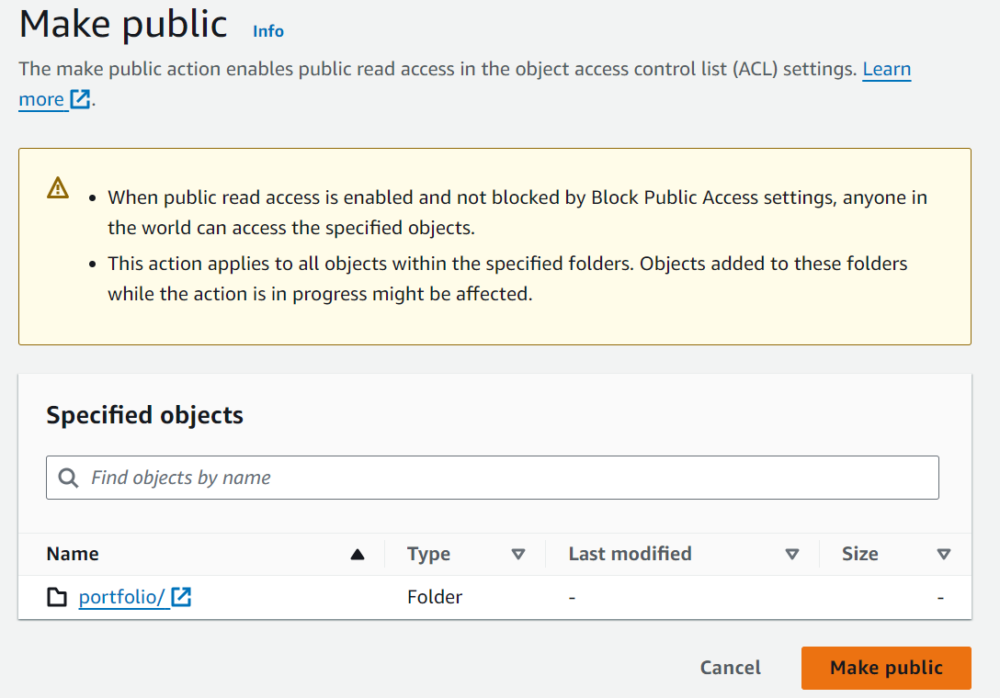



**Click on “Make public”, in order to apply changes made.**

**Step 6: Access your website**

**You can find your URL for accessing your static website under “Properties section”**

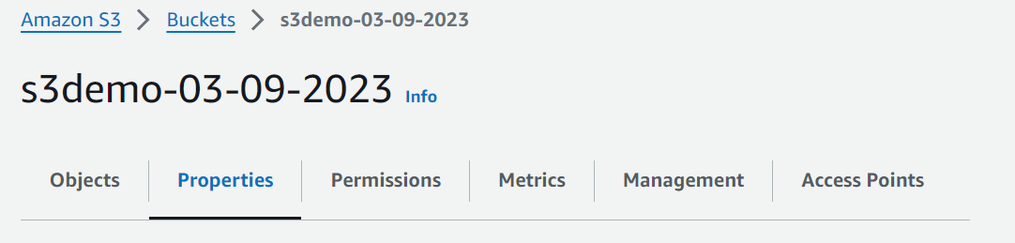



After making file public, your static website should be accessible at the endpoint provided under “Static website hosting”

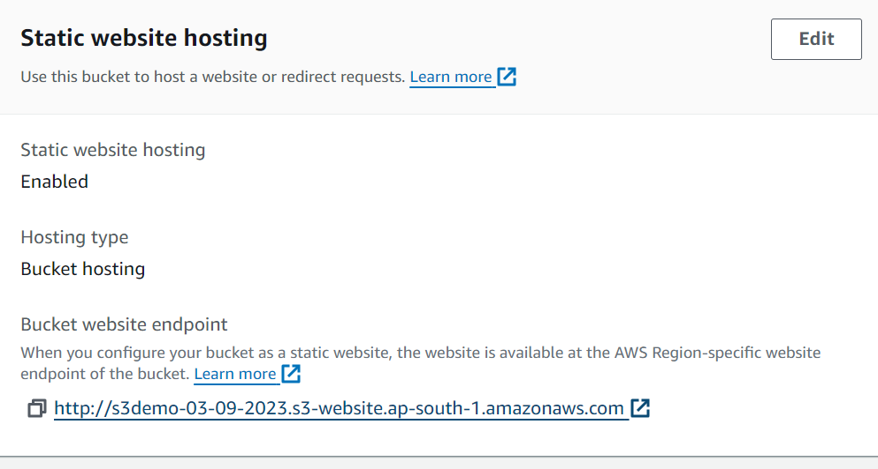



Thus, you can access your static website using this URL